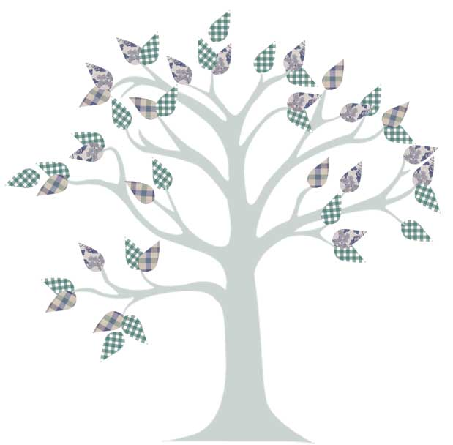

Maternal Great- grandmother

Maternal Great-grandfather

Maternal Great-grandmother

Paternal Great-grandfather

Paternal Great-grandmother

Paternal Great-grandmother

Maternal Grandmother

Maternal Grandfather

Paternal Grandmother

Paternal Grandfather

Mother

Father

Paternal Great-grandfather

Maternal Great-grandfather

Student Name