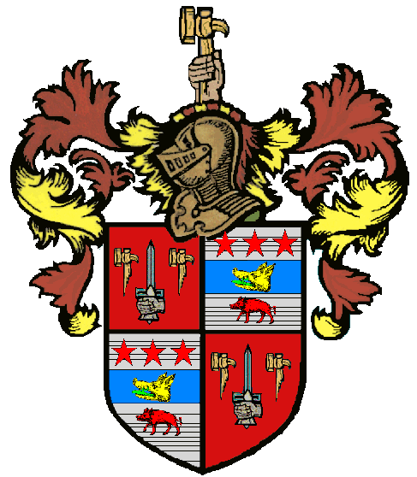
Family Crest
A Family Crest or Coat of Arms identified a person long before the use of family surnames (last names) became popular. These symbols were each unique and were not permitted by Royal Law to be duplicated. Each Coat of Arms and Family Crest is different.
Family Tree is a record of family members and relationships. It records the names of individual relations and describes their connection. A Family Tree begins with the oldest known ancestor(s) at the "top" of the tree and the youngest relative on the bottom. Eventually, this will form the "shape" of a tree. ***A sample will be sent home and you can access the Word document of the template on our websites.
Family Homework Activity
Your Family Crest is due_________________________________
*** Hand in your family tree to the crest***

Show and Tell
Explain to the class the research you did and the information you found. Show off the crest you and your family created, and explain the different features.
We will be presenting ___________________________________
Your assignment must include the following:
- Create a family crest to represent your family history.
- Use a large piece of poster board, at least 11” x 14”.
- Create a shape, and divide that shape into three or four equal sections.
- In each section, draw and color (paint colored pencil, crayon) a picture that represents one idea about your family.
- Some ideas that could represent your family’s histories or lives are the following:
- Flags that represent the countries your family came from
- Pictures of foods that are common to your ethnicity
- Pictures that represent your first or last name
- Drawings that depict favorite family events
- Photos that show family celebrations
- Make sure to have your family surname (last name) on the front of the crest!!
** Remember, this is family homework. Have fun researching your family and traditions. When it comes to family, they love to share stories and traditions, and if they don’t, be persistent! Most of all BE CREATIVE!
Questions to ask when researching
- What country did your parents, grandparents, great grandparents come from?
- What is a unique family tradition that your family practices?
- Are there any stories about your mom or dad’s side of the family that changed the history of your family?
Here are some resources to help you with your project
Sample Crests and Coat of Arms
http://www.fleurdelis.com/

Design a Coat of Arms (Discovery)
http://www.vam.ac.uk/vastatic/microsites/british_galleries/designa/coat_of_arms/coat_of_arms.html

Create a Coat of Arms http://www.imaginon.org/fun/whippingboy/createacoatofarms.asp?themeid=2&activityid=8

Sources:
http://www.ehow.com/about_5398361_definition-family-tree.html#ixzz1dD4ZE5ix

